New Megas:
Mega Luxray |  | Mega Infernape
Electric, Dark |  | Fire, Fighting
Ability: Strong Jaw |  | Ability: Ir
.baseHP = 95 |  | .baseHP = 76
.baseAttack = 130 |  | .baseAttack = 137
.baseDefense = 79 |  | .baseDefense = 71
.baseSpAttack = 110 |  | .baseSpAttack = 137
.baseSpDefense = 79 |  | .baseSpDefense = 71
.baseSpeed = 130 |  | .baseSpeed = 142
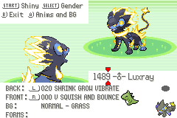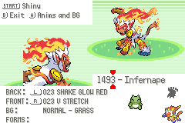
Mega Torterra |  | Mega Roserade
Grass, Ground |  | Grass, Poison
Ability: Ice Eater* |  | Ability: Technician
.baseHP = 115 |  | .baseHP = 60,
.baseAttack = 139 |  | .baseAttack = 70,
.baseDefense = 135 |  | .baseDefense = 85,
.baseSpAttack = 75 |  | .baseSpAttack = 150,
.baseSpDefense = 105 |  | .baseSpDefense = 120,
.baseSpeed = 56 |  | .baseSpeed = 130,
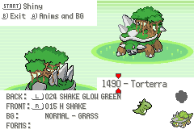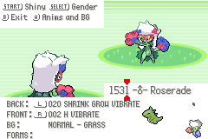
Mega Empoleon O |  | Mega Empoleon D
Water, Steel |  | Water, Steel
Ability: Emperor’s Presence* |  | Ability: Lightning Rod
.baseHP = 100 |  | .baseHP = 140
.baseAttack = 150 |  | .baseAttack = 75
.baseDefense = 75 |  | .baseDefense = 145
.baseSpAttack = 110 |  | .baseSpAttack = 75
.baseSpDefense = 75 |  | .baseSpDefense = 145
.baseSpeed = 120 |  | .baseSpeed = 50
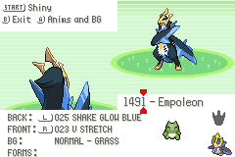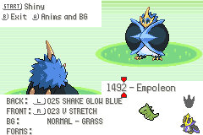

Mega Dusknoir |  | Mega Grimmsnarl
Ghost, Dark |  | Dark, Fairy
Ability: Prankster |  | Ability: Sheer Force
.baseHP = 105 |  | .baseHP = 115
.baseAttack = 110 |  | .baseAttack = 100
.baseDefense = 150 |  | .baseDefense = 95
.baseSpAttack = 65 |  | .baseSpAttack = 145
.baseSpDefense = 150 |  | .baseSpDefense = 95
.baseSpeed = 45 |  | .baseSpeed = 60
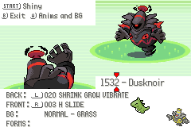

Mega Slaking
Normal
Ability: Comatose
.baseHP = 150
.baseAttack = 160
.baseDefense = 110
.baseSpAttack = 60
.baseSpDefense = 110
.baseSpeed = 110
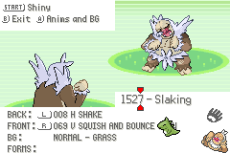

Differences from RR (I probably missed some):
- Hoenn Starters all learn their first elemental move (Ember, Absorb, Water Gun) at level 6
- All starters evolve at level 16 and 36
- Blaziken learns thunderous kick at level 64
- Latios/Latias learn Memento/Healing Wish at level 71 instead of 61, respectively
- Dusclops/Dusknoir get access to Amnesia as a level 1 move
- Empoleon learns Iron Head at level 42, can learn from ™ as well
- Urshifu gets signature move upon evolution
- Galarian Moltres learns Trick Room from ™
- Jircahi learns Moonblast from ™
- Dragapult learns Shadow Claw from ™
- Grimmsnarl learns Moonblast from ™
- Removed Speed Boost from Torchic / Combusken / Blaziken, now get Blaze, Early Bird, Striker (probably the only real nerf in the game)
- Removed Mega Alcremie
- Remove Nincada evolving into Shedinja, it’s catchable post game
- Ursaring evolves into Ursaluna at level 48 during day, Ursaluna-Bloodmoon at level 48 during night
- Alolan Marowak has Battle Armor instead of Bone Zone (ability not added)
- Mega Garbodor has Stench instead of Parasitic Waste (ability not added)
- Move Draco Barrage not yet added
- Move Soul Robbery not yet added
- Electivire is Electric/Fighting typing, Electrilizer and Magmarizer NOT reworked
- Silvally form changes with Typed Memory items
- Pecharunt retains Poison Puppeteer ability
- Bad Dreams ability does not bypass sleep clause
- Thunderous Kick and Axe Kick get boosted by Striker (they do not in RR)
- *New Ability: Ice Eater - functions like Water Absorb but for Ice-type moves; signature ability of Mega Torterra
- *New Ability: Emperor’s Presence - boosts own and ally’s Water and Steel type by 30%.

If you see any differences in stats, learnsets, evolution methods, etc that are NOT listed here, please report it so I can either fix it if it was unintentional or add it here!

